Window path format “D:/

• PowerShell is a command-line shell.
• PowerShell is a scripting environment.
• PowerShell is an automation engine.

A pipeline is a big name for a simple concept—a series of commands where the output of one becomes the input of the next
Basic navigation
Remove-item: (alias rm)
Move-item: (alias mv)
Get-Children: (alias ls used on folder)

You want to learn how a specific command works and how to use it.
Get-Help CommandName
or:
CommandName -?

native PowerShell command, call cmdlet
Powershell supports typing and many common Arithmetic operators.
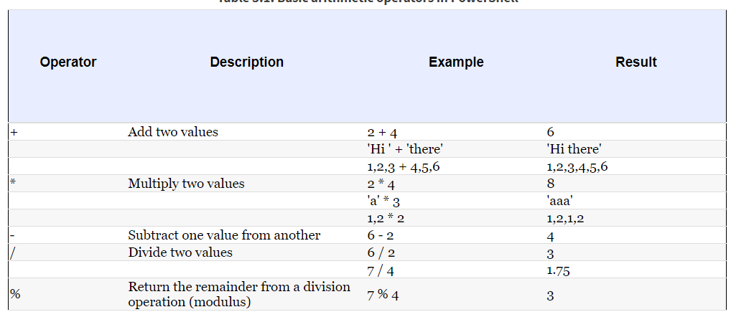

Output operation >
PS> (2+2)/2 > D:\result.txt output result to text file.
Variables:
$name-of-variable = value;
$value = 10 - 2;
$file = Get-Children ( variable can store the output of the command as well.)
Note : Collection in Powershell start at 0 not 1.

Command pipeline
Flow-control statements
while
PS> $i=0 PS> while ($i++ -lt 10) { if ($i % 2) {"$i is odd"}}

foreach :
PS> foreach ($i in 1..10) { if ($i % 2) {"$i is odd"}}

PS> 1..10 | foreach { if ($_ % 2) {"$_ is odd"}}

Scripts and functions
scripting
file called hello.ps1.
param($name = 'bub') "Hello $name, how are you?"
The parameter is given a default value of 'bub'.
Run script PS> .\hello Bruce
Creating function
function hello { param($name = "bub") "Hello $name, how are you" };
PS> hello Bruce
- The first category of command is a cmdlet. A cmdlet is implemented by a .NET class that derives from the Cmdlet base class in the PowerShell Software Developers Kit (SDK). This category of command is compiled into a dynamic link library (DLL) and then loaded into the PowerShell process, usually when the shell starts up. Because the compiled code is loaded into the process, it’s the most efficient category of command to execute. Cmdlets always have names of the form Verb-Noun, where the verb specifies the action and the noun specifies the object on which to operate.
- The next type of command is a function. This is a named piece of PowerShell script code that lives in memory as the interpreter is running, and is discarded on exit.
- A script command is a piece of PowerShell code that lives in a text file with a .ps1 extension. These script files are loaded and parsed every time they’re run, making them somewhat slower than functions to start
- The last type of command is called a native command. These are external programs (typically executables) that can be executed by the operating system. Because running a native command involves creating a whole new process for the command, native commands are the slowest of the command types.
Get-Command: alias to know the verbose command the alias represent
Aliases in PowerShell are limited to aliasing the command name only. Unlike in other systems such as Ksh, Bash, and Zsh, PowerShell aliases can’t include parameters.
PowerShell comments begin with a number sign (#) and continue to the end of the line.
PS> echo hi #there hi

<#
This is a comment
that spans multiple lines
#>
Pipelines and streaming behavior
pipeline is a series of commands separated by the pipe operator (|), as shown in figure 1.5. In some ways, the term production line better describes pipelines in PowerShell. Each command in the pipeline receives an object from the previous command, performs some operation on it, and then passes it along to the next command in the pipeline.

Streaming behavior occurs when objects are processed one at a time in a pipeline. This is one of the characteristic behaviors of shell languages. In stream processing, objects are output from the pipeline as soon as they become available.

